ANSWERS(ASSIGNMENT 7)

1) A Bash shell script is a text file containing a sequence of commands that are executed by the Bash shell, a command-line interpreter and programming language used in Unix-like operating systems. Bash scripts are used to automate repetitive tasks such as file management, software installation, and system backups by grouping commands into a single executable file.

Example;

gedit hello.sh #creates a file named hello.sh
Write command in file;
Echo “hello world” and save
Go back to terminal and run the command bash hello.sh

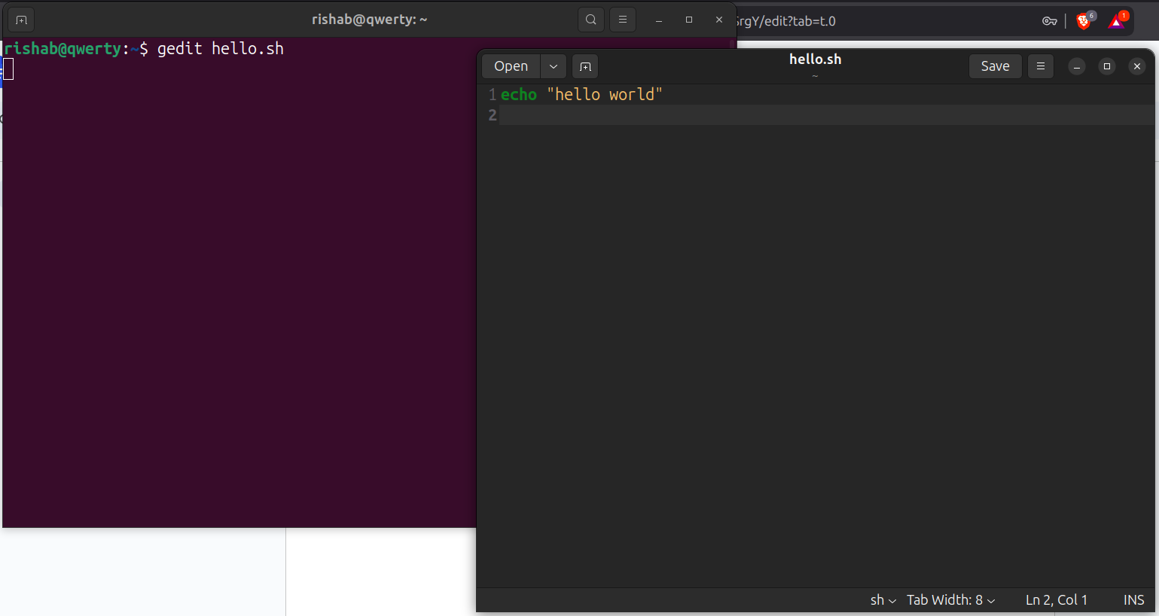

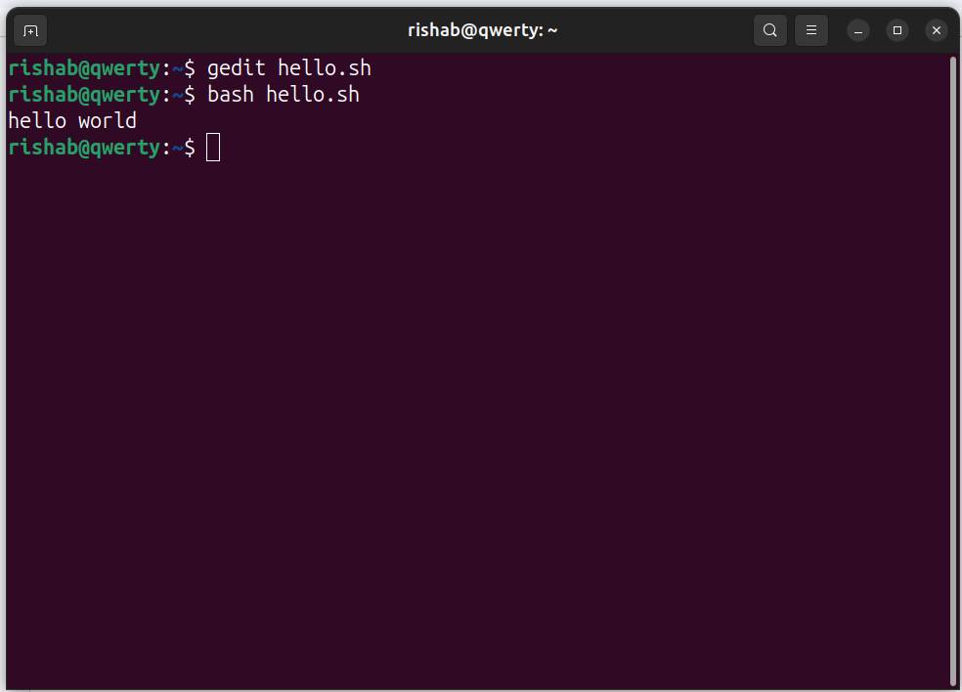

2) echo “hello world” (same as previous question example)


3) purpose of comments is to write anything for our reference without interfering in the program

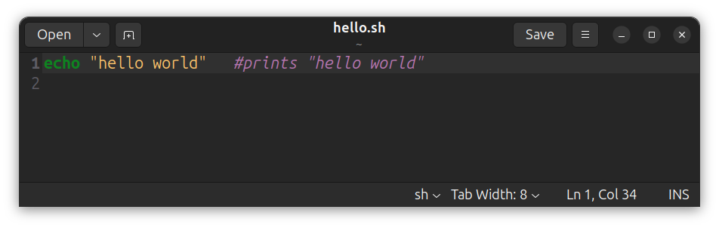

4) String variable
String is the default data type in BASH. 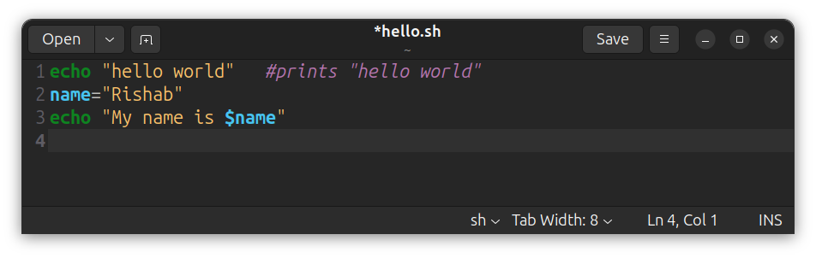
Integer variable
Use (( )) or let for integer arithmetic.
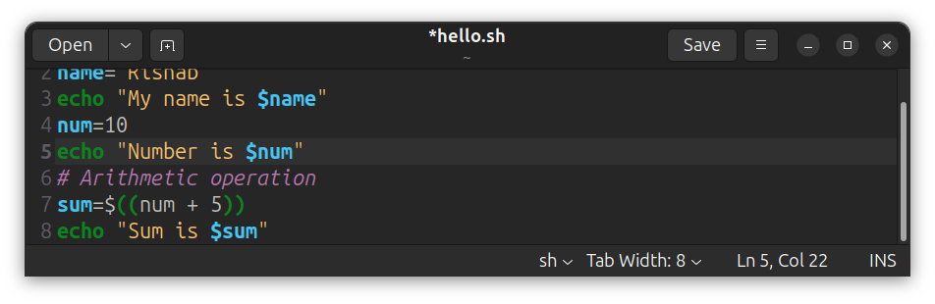

Float variable
BASH does not natively support float data type but ‘bc’ can be used.
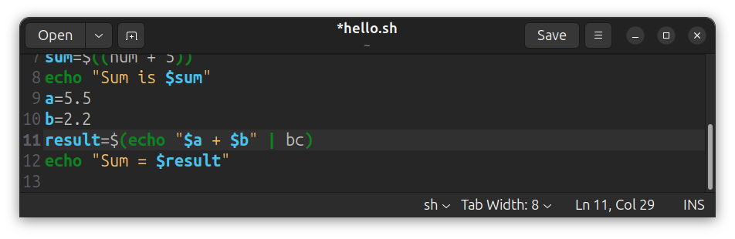

Double variable
Both float and double variable are same.’bc’ can also be used in double variable.

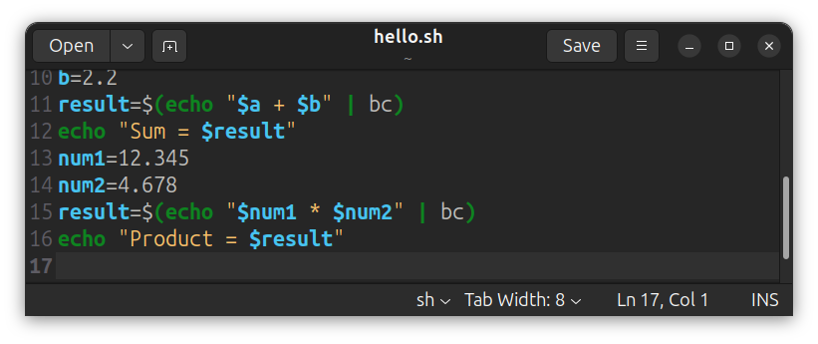
Boolean variable
We use if.
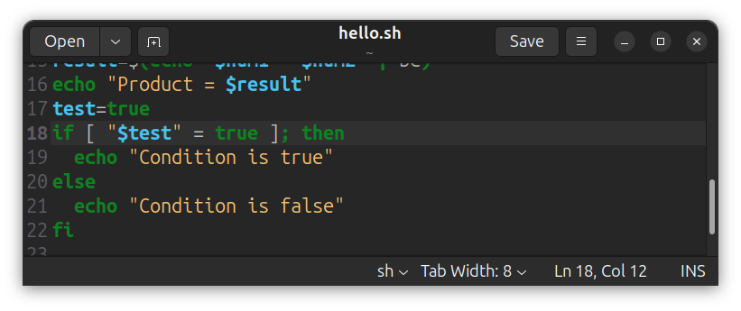
Character variable
Char data type is any data type with only one character. In this case we can say the character is a one letter string.

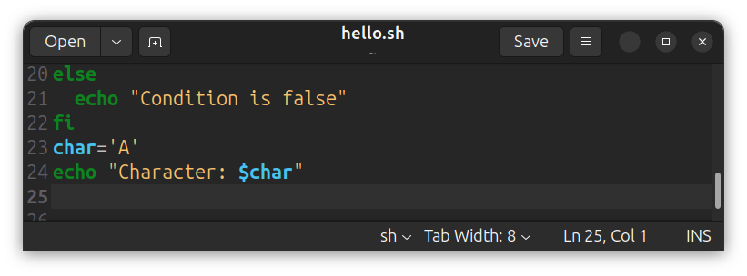

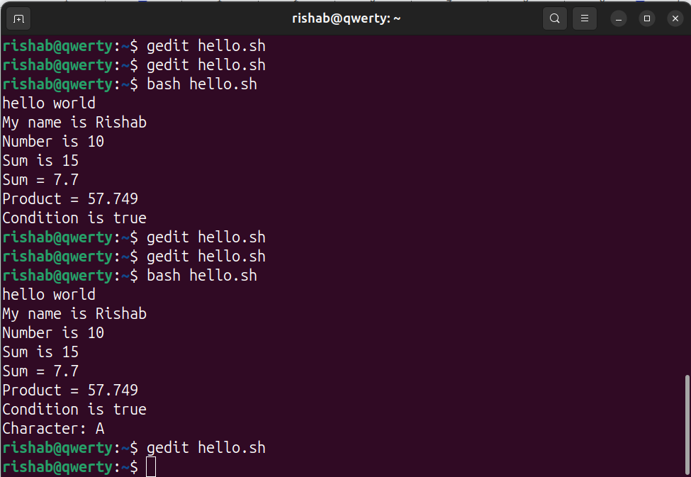

5) The shell script to display date and time is ‘echo $(date)’.
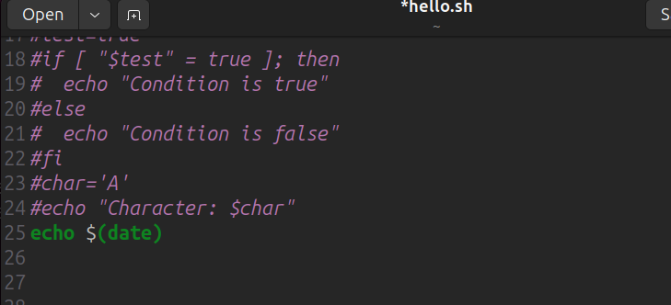

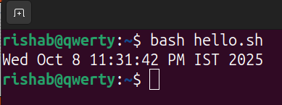

6)CONSTANTS VS VARIABLES

CONSTANT
[] Values cannot change once set.
[] For example, pi

VARIABLES
[] Values can be changed during execution.
[] For example, num1=10 num2=20

7)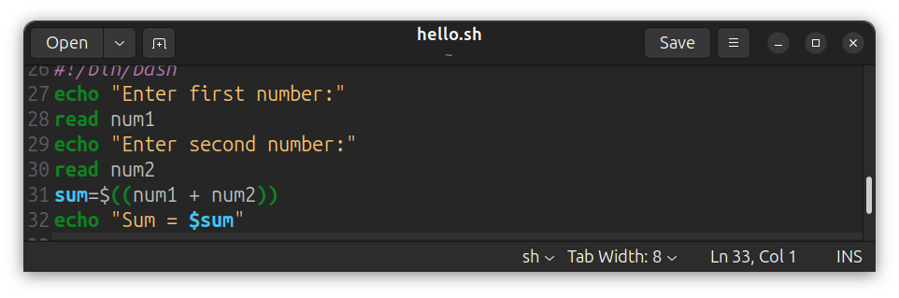
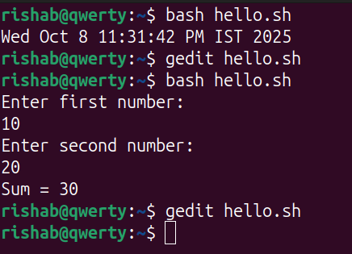

8) Using ‘source’ command we can execute the commands stored in another file in the same shell by typing source ‘filename’. This eliminates the need of opening another shell.

9) using -x option.
“Bash -x hello.sh”
Using the set method.
set -x # start debugging
echo "Debugging enabled"
set +x # stop debugging

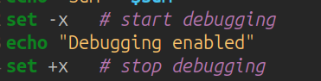

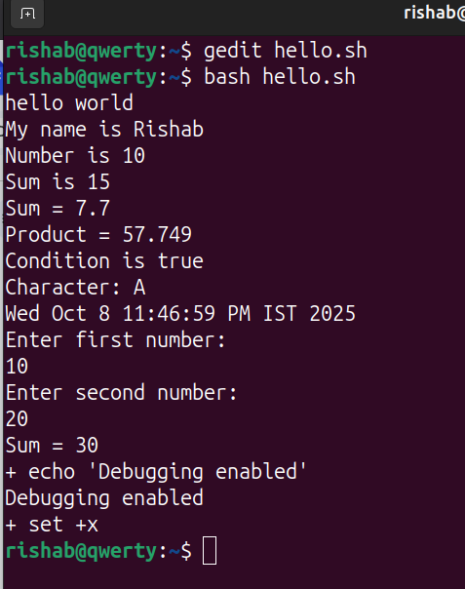

10)
